Does “Good Length Outside Off” Really Work? A Ball-Tracking Study of Wickets in the IPL

Yuvaan Pandey
UWCSEA Dover, Singapore
January, 2026

Abstract
Coaches and bowlers frequently assert that a good length just outside off stump maximizes dismissal probability in T20 cricket. This study evaluates that belief using ball-by-ball Hawkeye tracking data from the Indian Premier League by describing how wicket outcomes vary with pitching line (pitch_x) and length (pitch_y). After applying quality filters to pitch impact coordinates and ball speed, the final dataset contains roughly 140,000 legal deliveries, with wickets identified from dismissal metadata.
We use kernel density visualizations and zone-based wicket rates to compare wicket-taking deliveries against the overall targeting distribution, and we further examine how spatial patterns differ by bowling style. Across all deliveries, both general targeting and wicket locations concentrate in the traditional off-stump corridor, with wicket deliveries clustering more tightly and slightly fuller than non-wicket balls (roughly 4.5–7 m from the stumps). Zone-level summaries show the highest wicket rates in the Full and Bouncer/Very Short bands (≈6%), while Good Length and Yorkers are close behind and Short lengths are least effective.
Bowling styles show clear structural differences: pace wickets occur in a broader off-stump corridor with a wider length spread, while spin wickets form tighter, more central clusters nearer the stumps at shorter lengths (about 4–6 m). Leg spin produces the highest share of bowled and leg-before-wicket dismissals (over 50%), consistent with a more stump-targeted wicket mechanism than pace. Ball-speed distributions for seam bowling overlap heavily between wicket and non-wicket deliveries, suggesting that speed alone is not a strong driver of wickets in this dataset.
Overall, the results support the traditional “good length outside off” benchmark as a descriptive wicket-taking zone, while showing meaningful style-based differences in how wickets are generated. Because bowlers choose where to pitch strategically, these patterns should be interpreted as observational associations rather than causal effects.
Keywords: cricket analytics, Hawkeye, wicket probability, line and length, T20 cricket, Powerplay, spin versus pace

Introduction

Background and Context
In high level cricket, the concepts of line and length are essential to bowling tactics and strategy. Everyone, from coaches to commentators and players, emphasize that “a good length just outside the off stump” is the most important method for getting dismissals. This is often known as the “corridor of uncertainty”, as it is assumed the batter will be stuck in two minds and will play hesitantly. Despite its prominence in cricketing discourse, this is a claim that has not been validated by large-level aggregate data analysis, due to historic limitations in data availability and accurate measurement.

The emergence of ball tracking technologies has transformed the analytical landscape of cricket ((Hawk-Eye Innovations. Cricket ball-tracking technology overview. Hawk-Eye Innovations website. Accessed 12 Jan 2026.)).

With technological advances like ball-tracking we can now take a much more detailed look at the analytical landscape of cricket.

With great temporal and positional resolution, these systems record the spatial trajectory of every delivery, including the ball's exact pitching location, lateral deviation with respect to the stumps, and speed. Ball-level spatial data allows for a more understandable explanation of how wickets are really formed, whereas previous work in cricket analytics has mostly concentrated on match-level outcomes or player valuation. Crucially, ball-level spatial variables offer an interpretable structure that directly relates to bowling intent, making it possible to assess hypotheses regarding line, length, and dismissal risk in a manner that is not possible with aggregate or match-level results.

Twenty20 cricket provides a particularly compelling context for such analysis. The compressed nature of the format amplifies the importance of each delivery, encourages aggressive batting, and forces bowlers to operate under heightened risk-reward constraints. As a result, small differences in spatial targeting may carry meaningful consequences for wicket-taking probability. Understanding whether commonly cited “danger areas” on the pitch genuinely confer an advantage, and how these areas shift across match situations, remains an open empirical question.

Problem Statement and Rationale
Although coaching wisdom strongly asserts that specific regions of line and length are optimal for inducing dismissals, most supporting evidence is anecdotal or inferred from aggregate statistics. Existing academic studies in cricket analytics often report modest predictive power when relying on contextual or match-level features, while comparatively fewer studies examine ball-level spatial patterns in a systematic and hypothesis-driven manner. When spatial features are included, they are frequently discretized coarsely or treated descriptively, limiting their usefulness for tactical decision-making.

This gap is especially important in T20 cricket, where bowlers rarely deliver uniformly across the pitch. Instead, they select lines and lengths strategically, conditioned on phase of play, batter handedness, and bowling style. Any analysis that fails to account for this selection behavior risks conflating intent with effectiveness. A rigorous evaluation therefore requires both fine-grained spatial modeling and careful conditioning on match context. As a result, observed wicket locations reflect both bowler choice and batter response, making careful conditioning essential for separating spatial effectiveness from selective targeting.

The present study addresses this gap by estimating wicket probability as a smooth function of line and length, using high-resolution ball tracking data from the Indian Premier League. Rather than asking whether wickets occur in certain zones in absolute terms, we ask whether targeting specific regions yields measurable gains relative to where bowlers already choose to bowl, once low-support regions are masked and contextual factors are accounted for.

Significance and Purpose
This work contributes to cricket analytics in three key ways. First, it provides a quantitative test of long-standing coaching claims using ball-level spatial data, moving beyond intuition toward measurable effect sizes. Second, it demonstrates how wicket probability surfaces vary across bowling styles, phases of play, and batter handedness, highlighting that no single “optimal” line and length exists in isolation. Third, the analysis yields interpretable, situation-conditioned decision surfaces that can inform tactical planning without requiring opaque predictive models.

From a practical perspective, the findings are directly relevant to coaches and analysts seeking marginal gains in high-stakes environments such as the Powerplay². Even small absolute increases in wicket probability per ball can meaningfully influence match outcomes over the course of a tournament. At the same time, the study emphasizes the limits of spatial targeting alone, reinforcing the role of execution, deception, and contextual adaptation in elite bowling. The risk–reward framing is consistent with resource-based limited-overs models that treat remaining balls and wickets as joint scoring resources^{3,4}.

Throughout the study, visual analyses are used not as endpoints but as motivation for formal hypothesis testing, allowing intuitive cricketing concepts to be evaluated quantitatively.

Objectives
The study is guided by the following objectives (formalized as testable hypotheses grounded in cricketing intuition and evaluated using ball-level spatial data):

- To quantify how wicket probability varies across continuous dimensions of line and length in T20 cricket.
- To compare wicket-taking spatial patterns between pace and spin bowling styles.
- To evaluate how match phase moderates the effectiveness of commonly targeted regions, particularly in the Powerplay.
- To assess whether batter handedness induces systematic lateral shifts in wicket hotspots.
- To test whether ball speed exerts an independent effect on wicket probability after conditioning on line, length, and context.

Scope and Limitations
The analysis is restricted to men’s IPL matches with valid ball tracking data and focuses exclusively on legal deliveries. The primary explanatory variables are the ball’s pitching coordinates relative to the stumps, with supplementary splits by bowling style, match phase, and batter handedness. The study does not attempt to model batter skill, bowler intent explicitly, or fielding configurations, and therefore cannot establish causal effects. Accordingly, estimated wicket probability surfaces should be interpreted as conditional associations rather than causal effects.

Importantly, all findings should be interpreted as observational. Bowlers choose where to pitch the ball strategically, and regions with higher wicket rates may reflect selective use rather than intrinsic superiority. To mitigate this, low-support regions are masked and comparisons are made relative to empirical targeting distributions. Nevertheless, residual selection bias remains an inherent limitation⁵.

The analysis is grounded in a spatial risk-reward framework of bowling decision-making. In this view, each delivery represents a choice over a two-dimensional action space defined by line and length, with associated probabilities of conceding runs or taking wickets. Bowlers implicitly navigate this space based on match context, skill constraints, and perceived batter vulnerability. By estimating wicket probability surfaces conditioned on context, the study seeks to approximate the payoff structure underlying these decisions in a form that is both interpretable and empirically grounded.

Methodology Overview
Using ball-by-ball tracking data from the IPL, the study constructs a cleaned and standardized dataset of pitching locations, dismissal outcomes, bowling styles, match phases, and batter handedness. Zone-based aggregation and smooth spatial density approaches are used to estimate wicket probability. The Methods section that follows provides a detailed description of statistical processes, preprocessing steps, and methodological decisions.

Methods
We use ball-by-ball tracking from the HawkeyeStats IPL men’s dataset. The table includes batter and bowler identifiers, bowling style, ball speed, pitch impact coordinates (pitch_x, pitch_y), ball position at the stumps (stumps_x, stumps_y), post-contact landing on the field (field_x, field_y), runs, extras, and a text field with dismissal details. Match-level tags for format and gender are present.

Attribute | Description
match_id | Identifier for each match in the IPL dataset.
delivery | Number identifying each legal delivery within an over.
ball | Ball number (1-6) within an over.
batter | Name of the batter facing the delivery.
batter_id | Unique numeric identifier for the batter.
right_handed_bat | Boolean flag indicating whether the batter bats right-handed.
non_striker | Name of the non-striker at the opposite end.
non_striker_id | Unique numeric identifier for the non-striker.
bowler | Name of the bowler delivering the ball.
bowler_id | Unique numeric identifier for the bowler.
right_armed_bowl | Boolean flag indicating whether the bowler bowls with the right arm.
bowling_style | Type of bowling action (e.g., FAST_SEAM, MEDIUM_SEAM, OFF_SPIN, LEG_SPIN).
ball_speed | Recorded release speed of the delivery, measured in kilometers per hour (km/h).
runs | Total runs scored from the delivery, including extras.
batter_runs | Runs credited to the batter from the shot.
bowler_runs | Runs conceded by the bowler from the delivery.
extras | Runs not credited to the batter (e.g., wides, no-balls, leg-byes).
pitch_x | Horizontal (lateral) coordinate of the ball’s pitching location, measured in meters from the middle stump (negative = leg side, positive = off side).
pitch_y | Longitudinal coordinate of the ball’s pitching location, measured in meters from the stumps along the pitch (0 = base of stumps).
stumps_x | Lateral position of the ball when it passes the stumps, in meters.
stumps_y | Vertical height of the ball at the stumps, in meters.
field_x | X-coordinate of where the ball lands or is fielded after contact, measured across the field in meters.
field_y | Y-coordinate of where the ball lands or is fielded after contact, measured in meters from the pitch.
match_format | Match format indicator (T20, T10, etc.).
Table 1: Overview of all available features in the HawkeyeStats dataset.

Key variables used in this first pass:
- pitch_x lateral distance from middle stump in meters.
- pitch_y distance from the stumps along the pitch in meters.
- dismissal_details used to derive is_wicket (True if not null).
- bowling_style retained for later splits by bowler type.
- ball_speed for speed comparisons.

Processing and quality steps
- Standardize columns to lowercase snake cases.
- Remove outliers in pitch impact: keep pitch_x in [−2, 2] m and pitch_y in [0, 22] m. This removes obvious sensor or parsing errors seen in the raw scatter.
- Create labels: is_wicket = dismissal_details.notna().
- Define length zones that match coaching language:
  - Yorker 0.0-3.0 m
  - Full 3.0-5.5 m
  - Good length 5.5-7.5 m
  - Short 7.5-10.0 m
  - Bouncer or very short 10.0-22.0 m
- For speed plots, filter bad values by dropping missing speeds and anything under 10 km/h.
- After filtering, the working set has roughly 140k valid deliveries.

All plots in this section are simple seaborn KDEs or bar charts on the filtered frame. No oversampling or model fitting is used for these three figures^{8,9,10,11}.

Caveats and data considerations
- Context mixing: These first plots pool powerplay, middle, and death overs, and also pool pace and spin. Patterns can flip by phase and bowler type.
- Handedness: We did not separate right- and left-handed batters here. Line hot spots will shift across off-side vs leg-side.
- Measurement: Zone cutoffs are approximate. A sensitivity check around the 5.5 and 7.5 m boundaries is sensible.
- Speed quality: Some speeds were zero or implausible, so we filtered sub-10 km/h values before plotting.

Results
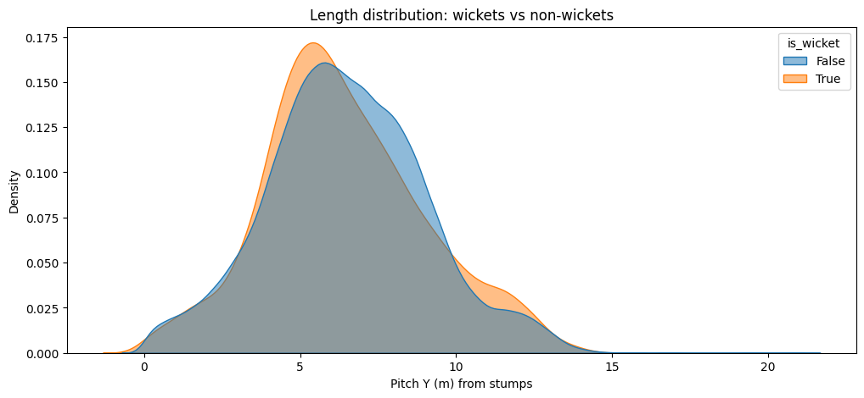
Figure 1. Raw length distributions all-balls vs wicket-balls.

This density comparison tracks the vertical coordinate Pitch_y, showing how far from the stumps the ball pitches.
Non-wicket balls span a wider range, while wickets cluster more tightly between roughly 4.5m-7m. The wicket curve leans slightly left (fuller lengths).

Suggests a fuller trajectory increases wicket probability, likely because it keeps the batter uncertain between front-foot and back-foot play. Extremely full or short lengths are less effective except in special contexts.

Quantifies the “corridor of dismissal” length coaches discuss.

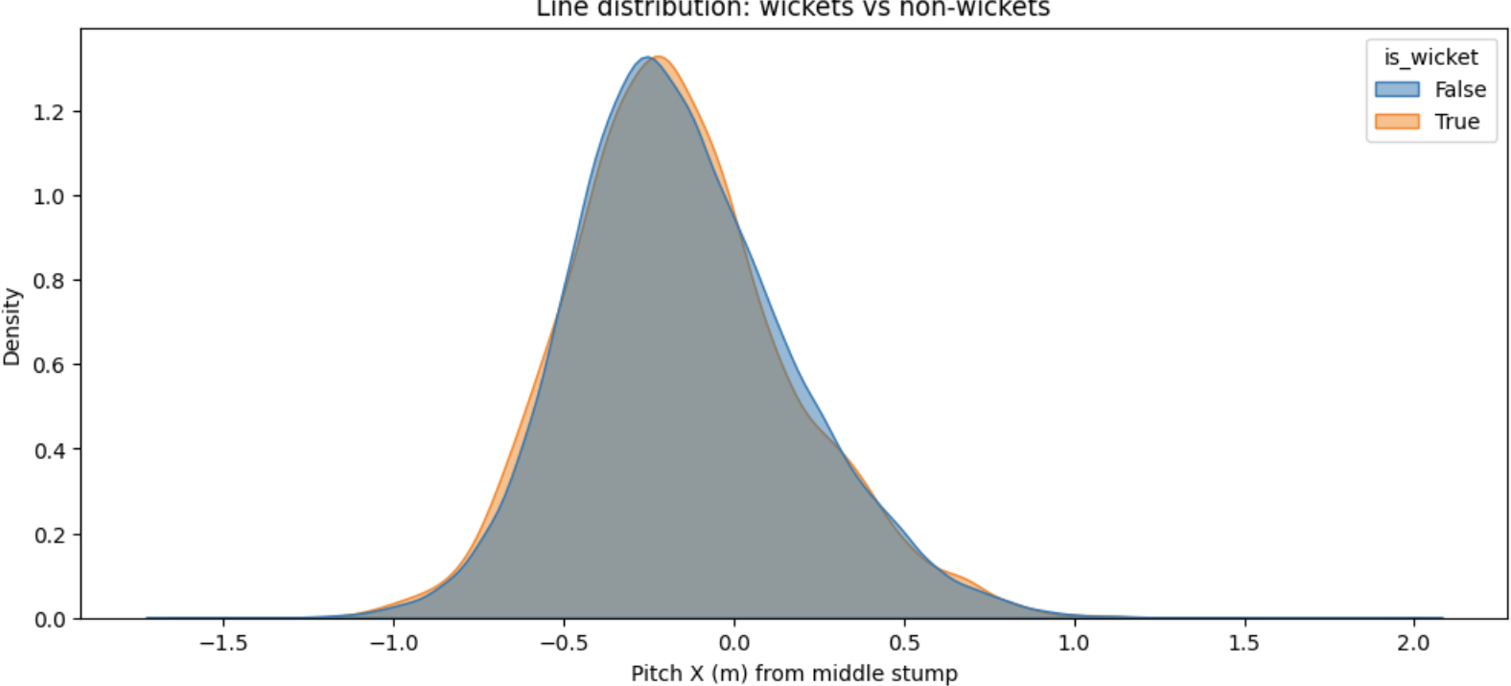
Figure 2. Pitch_y density: wickets vs non-wickets (narrower, slightly fuller).

A density plot comparing Pitch_x (horizontal line) distributions for wicket-taking and non-wicket deliveries.

Both curves peak near zero, showing that most deliveries land close to the stumps. The wicket curve is slightly narrower and more centered, implying fewer wide or leg-side balls result in dismissals.

Wickets occur when bowlers attack the stumps directly. Line consistency and precision appear crucial. Deviations wide off or down leg seldom create wicket opportunities.

Confirms that lateral accuracy, not just length, differentiates successful deliveries.

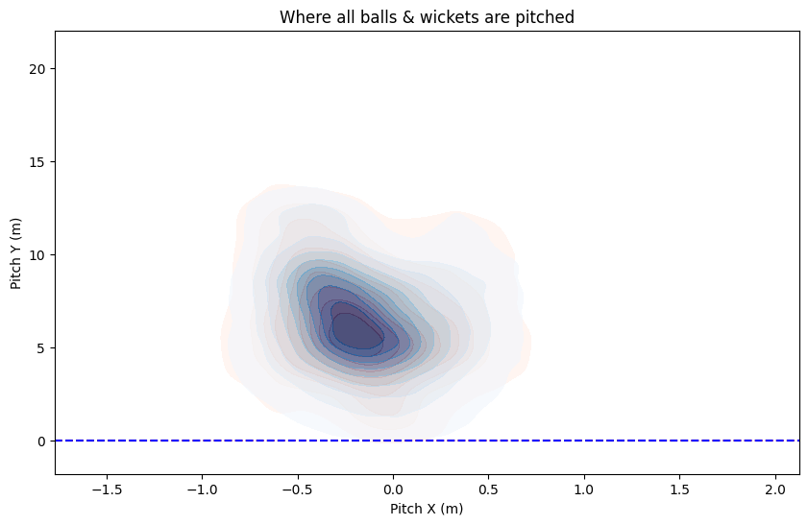
Figure 3. Pitch_x density: wickets closer to middle/off; deviations down leg/very wide underperform
This KDE heatmap overlays all deliveries and wicket deliveries on the same coordinate system^{6,7}. Pitch_x represents the lateral distance from middle stump, and Pitch_y measures how far down the pitch the ball lands. The darker zones indicate higher ball concentration.
The overall impact zone is centered just outside the off-stump corridor around 5-8 m from the stumps, which is the traditional “good length” region. The wicket heatmap tightens around that same channel but shifts slightly fuller, suggesting wicket balls tend to pitch marginally closer to the batter.

This reinforces the conventional understanding that a good-length line targeting the off-stump is the most threatening area. It also indicates bowlers consistently aim there, confirming reliable ball-tracking data quality.

This serves as the baseline for all subsequent analyses. Any deviation by bowler type or dismissal category can be compared against this reference distribution.

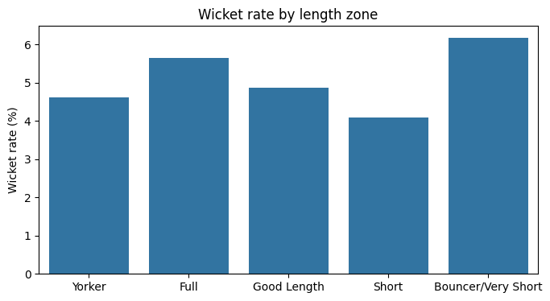

Figure 4. Wicket rate by length zone (bars).

Bar chart comparing wicket percentages across five pre-defined length zones: Yorker, Full, Good Length, Short, and Bouncer/Very Short.

The Full and Bouncer/Very Short zones exhibit the highest wicket rates (≈ 6%). Good Length and Yorker zones also perform respectably, while Short is least effective.

Fuller deliveries succeed through bowled/LBW dismissals, while short or bouncer balls likely yield top-edge catches in limited overs. The high bouncer figure may partly reflect fewer samples or death-over skew.

Reveals where wicket outcomes cluster tactically and provides a first numeric base for predictive modeling (e.g., logistic regression later).

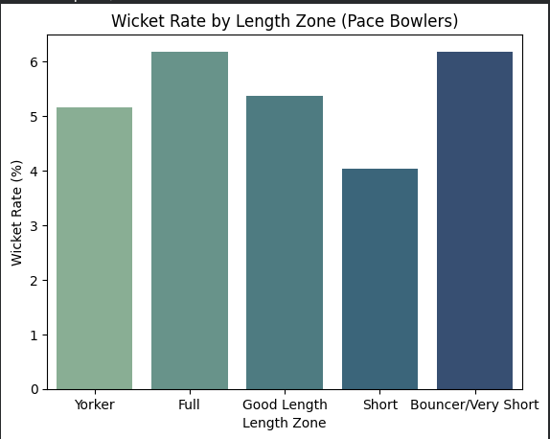

Figure 5. Bar chart to show wicket rate by length zone for pace bowlers

The chart above shows the percentage of wickets taken by pace bowlers across different length zones, categorized as Yorker, Full, Good Length, Short, and Bouncer/Very Short. The wicket rate measures the proportion of deliveries from each length that resulted in a wicket.

From the data, the Full and Bouncer/Very Short lengths record the highest wicket rates, both around 6%, followed closely by Good Length deliveries at about 5.4%. Yorkers contribute a slightly lower wicket rate at approximately 5%, while Short-pitched deliveries show the lowest effectiveness at around 4%.

These results suggest that pace bowlers achieve the greatest success either by attacking the stumps with fuller deliveries or by surprising batters with sharply rising short-pitched balls. The Full and Yorker lengths are often associated with bowled and leg-before-wicket dismissals, where the ball targets the base of the stumps. In contrast, the Bouncer/Very Short length may produce wickets through catches behind the wicket or at square-leg positions due to mistimed hook or pull shots.

The lower wicket rate from Short deliveries implies that while they may be useful for containment or building pressure, they are less likely to directly produce dismissals. This aligns with conventional cricketing understanding that successful fast bowling often relies on attacking the stumps or using bouncers sparingly as surprise weapons rather than as stock deliveries.

Overall, the results reinforce traditional coaching wisdom: pace bowlers are most effective when alternating between Full attacking lengths and well-directed bouncers, using these two extremes to unsettle and dismiss batters.

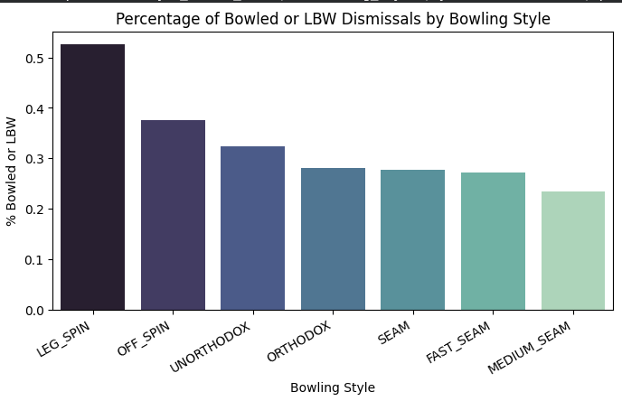
Figure 6: Percentage of wickets resulting from bowled or LBW dismissals by bowling style.

The chart illustrates the proportion of wickets that resulted from bowled or leg-before-wicket (LBW) dismissals across different bowling styles. These modes of dismissal generally occur when the bowler directly challenges the stumps, either by beating the batter’s defense or by trapping them in front.

The data shows that leg spin bowlers have the highest percentage of bowled or LBW dismissals, exceeding 50 percent of their total wickets. This finding highlights the attacking nature of leg spinners, who typically flight the ball and aim for the stumps, drawing the batter into risky drives. Off spinners follow next at around 38 percent, also demonstrating a tendency to target the stumps, although their lines are often slightly wider.

Among seamers, including fast, medium, and seam bowlers, the share of bowled and LBW dismissals is considerably lower, ranging between 25 and 28 percent. This lower percentage can be explained by the fact that seamers frequently induce edges rather than direct stump hits, leading to a higher number of caught dismissals in the slips or behind the wicket.

Interestingly, unorthodox and orthodox spin styles occupy a middle ground, suggesting that while they occasionally attack the stumps, their variations and wider angles of delivery produce a more balanced mix of wicket types.

Overall, the analysis indicates that leg spin bowling remains the most stump-targeted discipline, confirming its effectiveness in producing direct dismissals. This supports the traditional view that leg spinners, through turn and deception, create more bowled and LBW chances than any other bowling style.

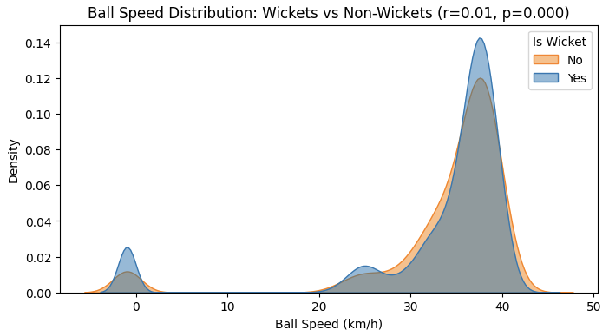
Figure 7: Kernel density distributions of ball speed for seam-bowling deliveries resulting in wickets versus non-wickets.

The figure above compares the distribution of ball speeds for deliveries that resulted in wickets versus those that did not, focusing on seam bowlers. The density curve represents how frequently certain ball speeds occur, with the height of the curve showing the relative concentration of deliveries within that range.

The y-axis represents density, a normalized measure of how concentrated deliveries are within a given range of ball speeds. Unlike raw frequency counts, density visualizations smooth out the distribution, showing where deliveries most commonly occur. The large peak between 35 and 42 m/s indicates that the majority of seam deliveries were bowled at typical professional speeds (approximately 125-145 km/h), while the near-zero cluster reflects sparse, likely erroneous readings.

Most deliveries cluster between 35 and 42 km/h (as per the raw data scale), with a secondary, smaller cluster at lower speeds. Both wicket and non-wicket distributions overlap almost entirely, meaning the proportion of wickets is nearly the same across the full speed range.

In simpler terms, faster deliveries do not necessarily produce more wickets among seam bowlers. This finding aligns with cricketing intuition that accuracy, movement, and variation often play a more decisive role than sheer pace. For instance, bowlers who can consistently pitch the ball in challenging areas may be just as effective, or even more so, than those who rely purely on speed.

The minor cluster near zero speed most likely represents data irregularities or misclassified deliveries, possibly due to incomplete tracking on slower or mismeasured balls. These anomalies have no meaningful impact on the broader analysis but are a reminder of the importance of preprocessing in large tracking datasets.

Overall, the visualization demonstrates that while pace defines the style of a seamer, it does not independently predict wicket-taking success. The results suggest that wicket probability in pace bowling arises from a combination of speed, precision, and contextual factors such as pitch conditions and batter behavior, rather than velocity alone.

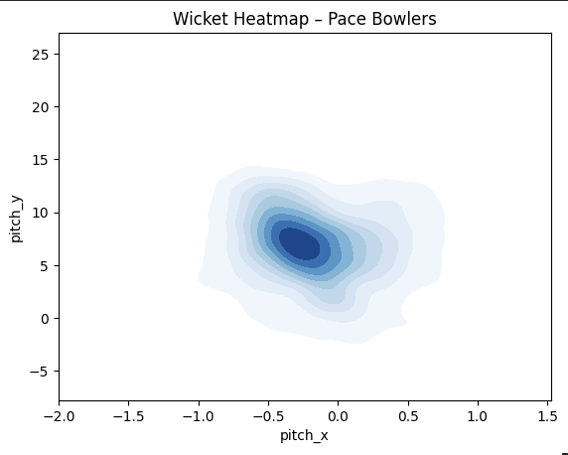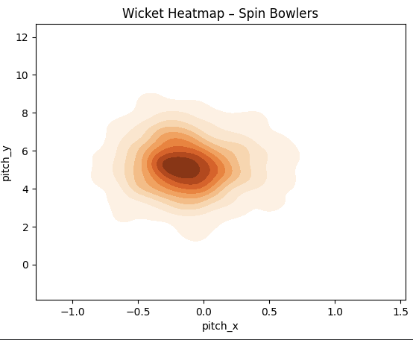
Figure 8: Spatial heatmaps of wicket-taking deliveries for pace (left) and spin (right) bowlers

The figures above compare the spatial distribution of wicket-taking deliveries for pace and spin bowlers. Each heatmap represents the density of deliveries that resulted in dismissals, plotted by their landing positions (pitch_x, horizontal line from middle stump; pitch_y, distance from the stumps). Darker regions indicate higher concentrations of wicket deliveries, showing where bowlers most frequently achieve success.

For pace bowlers, the hotspot is slightly outside the off stump (pitch_x ≈ -0.4 m) and within the good-to-full length range (pitch_y ≈ 6-8 m). This area aligns with the traditional “corridor of uncertainty,” where batters are forced to play at the ball but risk edging or misjudging movement. The density extends deeper toward fuller lengths, suggesting that many pace-bowler wickets also come from deliveries that challenge the stumps directly or induce mis-hits while driving. The shape of the cluster shows moderate variation in length and lateral deviation, consistent with the dynamic use of seam, swing, and bounce. This pattern reflects a balanced tactical approach: pace bowlers maintain an attacking line close to off stump but vary their length to exploit batter uncertainty between front- and back-foot strokes.

In contrast, spin bowlers exhibit a much tighter and more centralized wicket cluster. Their hotspot sits almost directly in line with the stumps (pitch_x ≈ 0 m) and slightly shorter in length (pitch_y ≈ 4-6 m). This compact concentration demonstrates greater precision and consistency compared to pace bowlers. Spinners typically aim to pitch the ball on a good length, where both turn and bounce are maximized, and where a batter’s defensive misjudgment is most likely to produce a wicket: either bowled, LBW, or caught close to the bat. The smaller spread indicates that spin bowlers rely more on subtle variations in flight, pace, and spin rather than on changes in line and length.
In other words, wicket-taking for spinners is achieved through deception and sustained accuracy rather than through variation in trajectory.

The distinction between the two heatmaps illustrates fundamentally different wicket-taking mechanisms.

Pace bowlers create dismissals through lateral movement and changes in length, exploiting both seam position and pitch conditions. Their wicket distribution extends over a wider area, reflecting diversity in approach (ranging from pitched-up swinging deliveries to back-of-a-length balls that rise and take edges).

Spin bowlers, by contrast, operate with a narrower spatial focus, targeting the stumps consistently. Their dismissals tend to result from sustained accuracy, turn, and tactical field setups that pressure batters into errors.

The vertical spread in the pace bowlers’ heatmap (extending beyond 10m) shows that they occasionally take wickets from shorter or fuller balls, aligning with match situations where bouncers or yorkers are used as attacking options. Spin bowlers, however, maintain a shorter vertical range, emphasizing a stable release point and targeting zone.

These patterns reinforce the idea that pace and spin rely on contrasting yet complementary strategies. Pace bowlers succeed by exploiting movement and variability around the off-stump corridor, while spinners focus on accuracy and direct stumps engagement. The findings echo established cricketing wisdom: speed offers opportunity through deviation, but spin prevails through precision and patience.

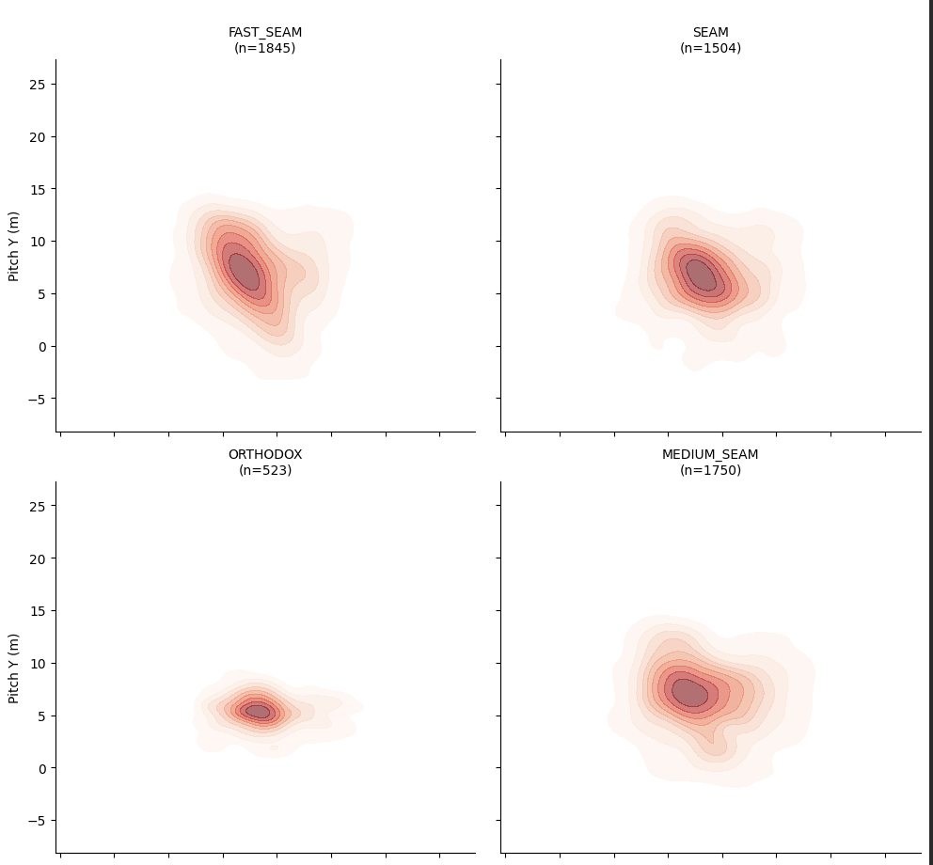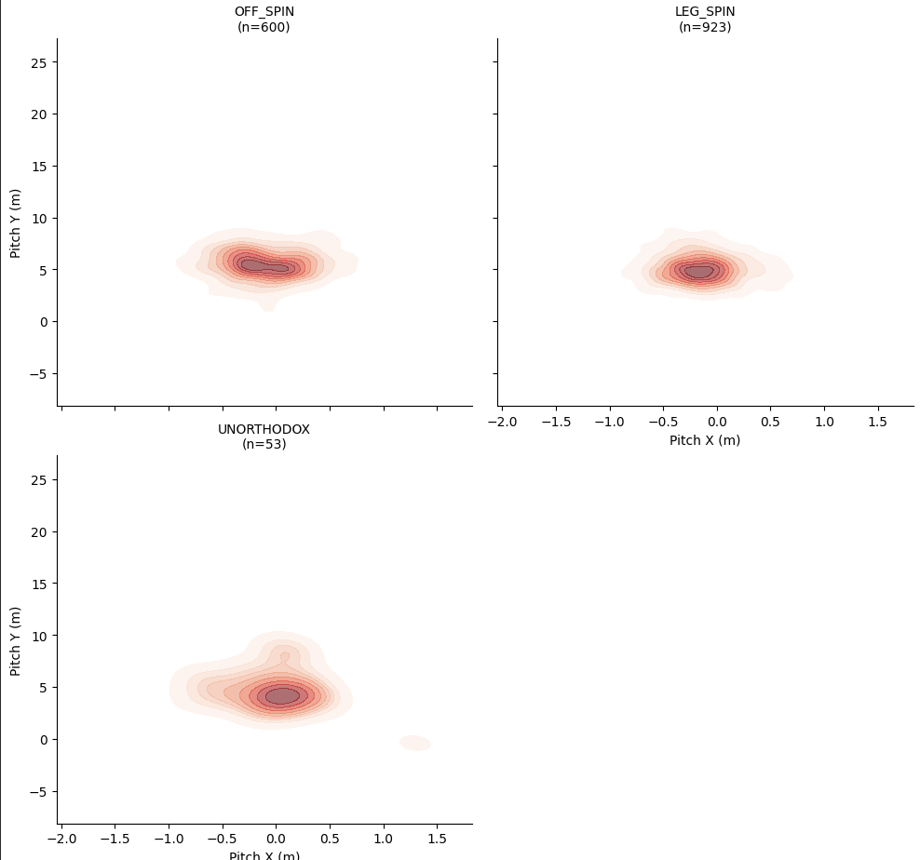

Figure 9: Wicket heatmaps by bowling style, showing the spatial density of wicket-taking deliveries in pitch coordinates.

The figure above displays wicket heatmaps for each bowling style, with contours indicating the density of wicket-taking deliveries in two-dimensional pitch coordinates. The sample size under each subplot (n) represents the number of deliveries that resulted in wickets within that style, which provides important context for interpreting the density distributions.

Fast seamers (n = 1,845) show a distinct hotspot just outside the off stump (pitch_x ≈ -0.4 m) and on a full-to-good length (pitch_y ≈ 6-8 m). This zone aligns closely with the “corridor of uncertainty” typically targeted in pace bowling. The contours indicate a balanced spread both vertically and horizontally, suggesting that wickets come from a range of lengths including fuller balls that swing and shorter deliveries that extract bounce. Seam bowlers (n = 1,504) display a similar but slightly more centralized pattern, implying that seamers bowl marginally straighter and rely on movement off the pitch rather than in the air. Both groups show vertical extension up to around 10 meters, indicating a mix of attacking lengths such as yorkers and back-of-a-length deliveries.

Together, these patterns support established cricketing principles: pace-generated wickets often result from deliveries that either draw false shots just outside off stump or trap batters with fuller, swinging balls. The difference between fast seam and seam bowlers highlights how speed and pitch conditions influence the precision and length required to create wicket opportunities.

Medium seamers (n = 1,750) exhibit a concentration slightly closer to the stumps (pitch_x ≈ -0.2 m) and at a more conservative length (pitch_y ≈ 7-9 m). The density contour appears broader but less intense, reflecting a style that prioritizes consistency over sheer pace. These bowlers often depend on lateral deviation, cutter variation, or subtle changes in release rather than high velocity. The relatively larger vertical spread implies that medium seamers adjust their lengths frequently to suit match situations, using slower balls and wobble-seam deliveries to create deception. The result is a wider dispersion of wicket points but with a focus on areas that challenge defensive technique.

Orthodox spinners (n = 523) show a compact hotspot centered almost directly in line with the stumps (pitch_x ≈ 0 m) and at a length of 4-6 meters. The limited spread along both axes reflects high accuracy and control. This position is optimal for inducing LBW or bowled dismissals, as it forces the batter to play at deliveries that can turn in or straighten. The smaller dataset means some caution should be taken when generalizing, but the pattern reinforces the classical spin approach of attacking the stumps and maintaining a probing line.

Unorthodox spinners (n = 53), while represented by a smaller sample size, show a slightly fuller average length (pitch_y ≈ 5-7 m) and a wider horizontal dispersion. This spread likely reflects their more varied release points and flight trajectories, as unorthodox bowlers depend on unpredictability rather than repetition. However, the low sample count limits statistical confidence, suggesting that further data collection is needed to establish robust conclusions for this group.

Off spinners (n = 600) demonstrate a dense cluster just outside off stump on a moderate length (pitch_y ≈ 5-6 m). The proximity of this hotspot to the stumps indicates an attacking intent, with wickets commonly achieved through turn that beats the inside edge or through induced mis-hits when batters attempt to drive. The distribution’s slight skew toward the off side is consistent with traditional right-arm off-spin lines bowled to right-handed batters.

Leg spinners (n = 923), by contrast, show a hotspot similar in depth (pitch_y ≈ 5-6 m) but more centered on the middle stump. This difference reflects their natural variation: leg breaks and googlies that attack both edges of the bat. The density contour is slightly wider, suggesting a more diverse mix of release trajectories and spin magnitudes. Despite this variability, the central cluster supports the idea that leg spinners are the most direct stumps-targeting variety, capable of producing both bowled and LBW dismissals. The relatively larger sample size adds confidence to these observations.

Across bowling styles, several key trends emerge:
Pace-oriented bowlers (fast, seam, and medium seam) generate wickets from a broader range of lines and lengths, emphasizing the value of movement and variation.
Spin bowlers (off, leg, orthodox) concentrate their efforts nearer to the stumps, prioritizing accuracy, flight, and turn.
The tighter clusters in spin bowling plots contrast with the diffuse zones for pace bowlers, showing how wicket-taking methods differ: consistency and deception versus speed and variability.
Sample size differences are also instructive. The much larger datasets for fast seamers and seamers provide robust statistical reliability, while smaller samples for spin types, particularly unorthodox bowlers, highlight the need for cautious interpretation.

Discussion
In T20 cricket, the pooled line and length distributions offer a helpful starting point for figuring out where bowlers actually play. Pitching positions are concentrated between five and eight meters from the stumps and just outside the off stump on all deliveries. This area closely resembles the conventional phrase "good length just outside off," which predominates in professional coaching terminology. Bowlers regularly target this area, as shown by the density of deliveries here, making it a suitable benchmark for assessing wicket-taking effectiveness.

Fuller and good-length deliveries have greater dismissal rates than short-pitched balls when wicket rates are calculated within discrete length zones. In line with their function as an attacking option in death overs, when bowled and LBW dismissals are more frequent, Yorkers also produce a significant number of wickets. The short-length category, on the other hand, displays lower total wicket rates, indicating that short balls are often used as setup deliveries or for containment than as the main way of getting wickets.

The comparatively high wicket rate seen in the bouncer or extremely short-length zone is one unexpected signal in the pooled study. There are two possible explanations. First, phase mixing is probably the cause of this unusual occurrence. In the last overs, short-pitched deliveries are used sometimes with leg-side fields set to turn missed hooks or pulls into catches. Second, the new classification combines more defensive short balls with controlled bouncers to create a single category for deliveries longer than ten meters. The zone's apparent effectiveness may be exaggerated by this aggregation. These findings encourage more phase and bowling style stratification.

There is a definite contraction for wickets when comparing the vertical pitch distributions of deliveries that take wickets and those that do not. Wickets are grouped in a smaller, slightly fuller band, whereas non-wicket balls vary widely from about 4 to 10 meters. The idea that deliveries that require batters to commit forward while still posing a threat to lateral movement are more likely to result in dismissals is supported by this trend. While very short balls seem to produce wickets mostly in particular tactical situations rather than as a general approach, extremely full deliveries are nonetheless effective but more difficult to execute consistently.

This conclusion is supported by the wicket-only heatmaps. Wicket locations compress toward a tighter corridor that is slightly fuller and near the off-stump channel in relation to the total delivery distribution. This contraction implies that successful deliveries are those that reduce the batter's window of opportunity rather than just those that occupy common areas. These deliveries raise the possibility of a technical error by threatening both edges of the bat while staying near the stumps.

Furthermore, comparing bowling styles reveals notable differences. With dismissals occurring across a wider variety of lengths and lateral deviations, pace bowlers show broader wicket-taking regions. This spread illustrates how speed, bounce, and seam movement contribute to uncertainty. Fuller deliveries that test the stumps and back-of-a-length balls that produce edges through bounce combine to produce wickets. The range of these areas suggests that, rather than exact accuracy, pace bowling depends on variation and the situational application of various lengths.

In comparison, the wicket clusters of spin spinners are much closer together and more concentrated. Their hotspots are localized at significantly shorter lengths and nearer the stumps. Dismissals are the result of persistent pressure rather than surprise, and this compactness shows a dependence on accuracy and repeatability. Because they can attack both sides of the bat with turn and variation, leg spinners in particular have a significant tendency to produce bowled and LBW dismissals.

When combined, these patterns show complimentary processes for taking wickets. While spin bowlers derive value from precise aim and pressure, pace bowlers take advantage of variations in trajectory and bounce to produce errors throughout a larger spatial envelope. The findings support long-standing coaching intuition while also revealing its shortcomings. Although the "good length just outside off" is still a useful benchmark, bowling technique, match phase, and execution all affect how successful it can be. In some situations, especially during the Powerplay, aiming by itself can yield modest benefits; nonetheless, it cannot function without skill and situational awareness.

Acknowledgments
I would like to thank my parents & school for their continued support.

References
1. Hawk-Eye Innovations. Cricket ball-tracking technology overview. Hawk-Eye Innovations website. Accessed 12 Jan 2026.
2. International Cricket Council. ICC Men’s T20I Playing Conditions: Fielding Restrictions (Powerplay). International Cricket Council. Accessed 12 Jan 2026.
3. Duckworth FC, Lewis AJ. A fair method of resetting the target in interrupted one-day cricket matches. Journal of the Operational Research Society. 1998;49(3):220–227.
4. Stern SE. The Duckworth–Lewis–Stern method: extending the Duckworth–Lewis methodology to deal with modern scoring rates. Journal of the Operational Research Society. 2016;67(12):1469–1480.
5. Hernán MA, Robins JM. Causal Inference: What If. Boca Raton (FL): Chapman & Hall/CRC; 2020.
6. Silverman BW. Density Estimation for Statistics and Data Analysis. London: Chapman & Hall; 1986.
7. Scott DW. Multivariate Density Estimation: Theory, Practice, and Visualization. 2nd ed. Hoboken (NJ): Wiley; 2015.
8. McKinney W. Data structures for statistical computing in Python. In: van der Walt S, Millman J, editors. Proceedings of the 9th Python in Science Conference (SciPy 2010). 2010. p. 56–61.
9. Harris CR, Millman KJ, van der Walt SJ, et al. Array programming with NumPy. Nature. 2020;585(7825):357–362. doi:10.1038/s41586-020-2649-2
10. Waskom ML. seaborn: statistical data visualization. Journal of Open Source Software. 2021;6(60):3021. doi:10.21105/joss.03021
11. Hunter JD. Matplotlib: A 2D graphics environment. Computing in Science & Engineering. 2007;9(3):90–95. doi:10.1109/MCSE.2007.55

